Application of Residue Theorem

Evaluation of Real Definite Integrals by Contour Integrals:
A large number of real definite integrals, whose evaluation by usual methods become sometimes very tedious, can be easily evaluated by using Cauchy’s Residue theorem. For finding the integrals we take a suitable complex function and closed curve , then find the poles or singularity of the function and calculate residues at those poles only which lie within the curve . Then using Cauchy’s residue theorem we have
We call the curve, a contour and the process of integration along a contour is called contour integration.
(Improper Integral) Infinite real integrals of the form or, where and are polynomials in . Such integrals can be reduced to contour integrals, if
- has no real roots.
- The degree of is greater than that of by at least two.
Procedure to solve:
To evaluate such integrals we consider the contour integrals  where C is the closed contour, consisting the real axis from to and the upper half of the circle i.e.,  - - - - (1) | 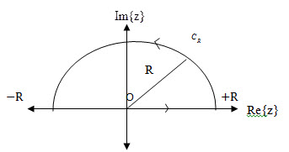

Now using CRT we get,
Then (1) becomes,
- -- -- --- --- (2)
Now, on the semi circular path , . Then applying Jordan’s Lemma,
Then (2) reduces to

Example 7.5: Evaluate by using contour integration.
Solution:

We consider where C is the closed contour consisting of the semi circle of radius R together with the part of the real axis –R to +R. i.e.,
……(1)
Now the first integral has singularities or pole at i.e. of order 2. But the only pole is inside the contour C. So,
So by CRT,
So equation (1) becomes

By Jordan Lemma letting and noting that the second integral in left hand side would become zero.
Hence,
Example 7.6: Evaluate by using contour integration.
Solution: We consider where C is the closed contour consisting of the semi circle of radius R together with the part of the real axis –R to +R. i.e.,
……(1)
The figure in the previous example should be considered here.
Now the first integral has singularities or poles at
When
i.e. there are four poles, but only two poles at and lie within the contour C. So,
$$B_{0}=\frac{1}{4z_{0}^{3}}=\frac{1}{4}z_{0}^{-3}=\frac{1}{32}e^{-i\frac{3π}{4}} \\ B_{1}=\frac{1}{4z_{1}^{3}}=\frac{1}{4}z_{1}^{-3}=\frac{1}{32}e^{-i\frac{9π}{4}}$$
So by CRT,
So equation (1) becomes
.
By Jordan Lemma letting and noting that the second integral in left hand side would become zero. Hence,

Matlab command for improper integral:
- Evaluate $\int_{0}^{∞}{\frac{dx}{x^{2}+1}}$,  >> fun=@(x) 1./(x.^2+1);  >> q=integral(fun,0,inf)  q = 1.5708 | - Evaluate $\int_{-∞}^{∞}{\frac{dx}{{{(x}^{2}-2x+2)}^{2} }}$,  >> f=@(x) 1./(x.^2-2.*x+2).^2;  >> q=integral(f,-inf,inf)  q = 1.5708
Sample Exercise Set on Improper Integral:
Integration of the form (improper integral)
1. Evaluate the following improper integral using Cauchy’s residue theorem (CRT):
(i) (ii)
(iii) (iv)
(v)
Laurent series generalize Taylor series. Indeed, whereas a Taylor series has positive integer powers
(and a constant term) and converges in a disc, a Laurent series is a series of positive and negative
integer powers of $(z-z_{0})$ and converges in an annulus (a circular ring) with center $z_{0}$ . Hence by a
Laurent series we can represent a given function $f(z)$ that is analytic in an annulus and may have
singularities outside the ring as well as in the “hole” of the annulus.

Laurent’s Theorem:
Let $f(z)$ be analytic in a domain containing two concentric circles $c_{1 }$and $c_{2 }$with center $z_{0 }$ , radii
$R_{1 }$and $R_{2 },$ ${(R}_{1 }<R_{2 })$ and the annulus between them. Then$f(z)$ can be represented by the Laurent
series
$$f\left(z\right)=\sum_{n=0}^{∞}{a_{n}{\left(z-z_{0}\right)}^{n}}+\sum_{n=1}^{∞}{\frac{b_{n}}{{\left(z-z_{0}\right)}^{n}}}$$  $$=a_{0}+a_{1}\left(z-z_{0}\right)+a_{2}{\left(z-z_{0}\right)}^{2}+…$$  $+\frac{b_{1}}{\left(z-z_{0}\right)}+\frac{b_{2}}{{\left(z-z_{0}\right)}^{2}}$+ $\frac{b_{3}}{{\left(z-z_{0}\right)}^{3}}+…$ | 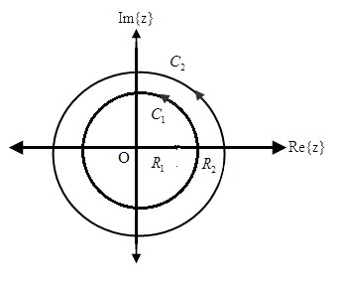
The coefficients of Laurent series are given by the integrals
$${a_{n}=\frac{1}{2πi}\oint_{c}^{.}{\frac{f(z^{*})}{{(z^{*}-z_{0})}^{n+1}}} dz^{*}}_{ }, { b}_{n}=\frac{1}{2πi}\oint_{c}^{.}{{(z^{*}-z_{0})}^{n-1}} f\left(z^{*}\right) dz^{*}$$
The variable of integration is denoted by $z^{*}$ , since $z$ is used in Laurent series.
The existing negative power of$(z-z_{0})$ is known as principal part. If there is finite number of terms
in the principal part of $f\left(z\right)$ in the Laurent series expansion then the coefficient of $\left(\frac{1}{z-z_{0}}\right)$ is called the
residue of $f\left(z\right)$ at pole$z=z_{0}.$

Laurent series expansion
Example: 7.7 Obtain Laurent series expansion of when , .
Solution: (i) Since $1<\left|z\right|<2$

$\frac{1}{z}<1$ and $\frac{\left|z\right|}{2}<1$

$∴ \frac{1}{\left|z^{2}\right|}<1$ and $\frac{\left|z\right|}{2}<1$

Let $\frac{1}{{(1+z}^{2})(z+2)}≡\frac{Az+B}{{1+z}^{2}} +\frac{C}{z+2}$

$$∴1≡\left(Az+B\right)\left(z+2\right)+C(1+z^{2})$$
At, $z=-2, 5C=1 ∴C=\frac{1}{5}$
Equating coefficients of $z^{2} ; A+C=0 ∴A=-C=-\frac{1}{5}$
Equating coefficients of $z ; 2A+B=0 ∴B=-2A=\frac{2}{5}$
$∴\frac{1}{{(1+z}^{2})(z+2)}=\frac{-\frac{1}{5}z+\frac{2}{5}}{{1+z}^{2}}+\frac{\frac{1}{5} }{z+2}$
$=\frac{2}{5}\frac{1}{{1+z}^{2}}-\frac{1}{5} \frac{z}{{1+z}^{2}}+\frac{1}{5}\frac{1 }{z+2}$
$=\frac{2}{5}\frac{1}{z^{2}(1+\frac{1}{z^{2}})}-\frac{1}{5} \frac{z}{z^{2}(1+\frac{1}{z^{2}})}+\frac{1}{5}\frac{1 }{2(1+\frac{z}{2})}$
$=\frac{2}{5z^{2}}{(1+\frac{1}{z^{2}})}^{-1}-\frac{1}{5z} {(1+\frac{1}{z^{2}})}^{-1}+\frac{1}{10}{(1+\frac{z}{2})}^{-1}$
$=\frac{2}{5z^{2}}\left(1-\frac{1}{z^{2}}+\frac{1}{z^{4}}-\frac{1}{z^{6}}+…\right) -\frac{1}{5z} \left(1-\frac{1}{z^{2}}+\frac{1}{z^{4}}-\frac{1}{z^{6}}+…\right)$
$+\frac{1}{10}(1-\frac{z}{2}+\frac{z^{2}}{4}-…)$
which is the required Laurent series.
(ii) For $\left|z\right|>2$ we have $\frac{\left|z\right|}{2}>1 \frac{2}{\left|z\right|}<1$
Also $\frac{1}{\left|z^{2}\right|}<1$
$∴\frac{1}{{(1+z}^{2})(z+2)}=\frac{2}{5}\frac{1}{{1+z}^{2}}-\frac{1}{5} \frac{z}{{1+z}^{2}}+\frac{1}{5}\frac{1 }{z+2}$
$=\frac{2}{5}\frac{1}{z^{2}(1+\frac{1}{z^{2}})}-\frac{1}{5} \frac{z}{z^{2}(1+\frac{1}{z^{2}})}+\frac{1}{5}\frac{1 }{z(1+\frac{2}{z})}$
$=\frac{2}{5z^{2}}{(1+\frac{1}{z^{2}})}^{-1}-\frac{1}{5z} {(1+\frac{1}{z^{2}})}^{-1}+\frac{1}{5z}{(1+\frac{2}{z})}^{-1}$
$=\frac{2}{5z^{2}}\left(1-\frac{1}{z^{2}}+\frac{1}{z^{4}}-\frac{1}{z^{6}}+…\right)-\frac{1}{5z} \left(1-\frac{1}{z^{2}}+\frac{1}{z^{4}}-\frac{1}{z^{6}}+ ……\right)$
$+\frac{1}{5z}\left(1-\frac{2}{z}+\frac{4}{z^{2}}-…\right).$
which is the required Laurent series.

Sample Exercise Set on Laurent Series:
State Laurent series. Expand in a Laurent series valid for
.
- Expand in a Laurent series valid for
.
- Expand in a Laurent series valid for
- Find the function, and the region of convergence for the following series:
- Given functions (i) [Figure: (a) and (b)] and (ii) .
[Figure: (a) and (c)] Determine the region of convergence and the series for the following figures:
(a)  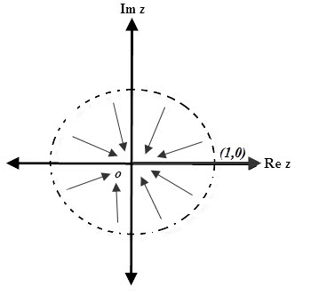 | (b)  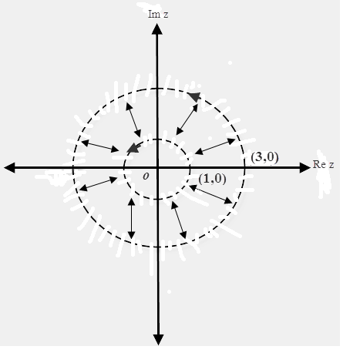 | (c)  